**FOOD DELIVERY MANAGEMENT SYSTEM**

A MINI PROJECT REPORT

SUBMITTED BY

**HARSHATH V 221701019**

**JANAKIRAMAN K 221701023**

**JUNIDE CHRIS A 221701026**

**KEERTHI AACHUTHAN K 221701030**

In partial fulfillment for the award of the degree of

**BACHELOR OF ENGINEERING**

**IN**

**COMPUTER SCIENCE AND DESIGN**

**RAJALAKSHMI ENGINEERING COLLEGE**

**THANDALAM**

**CHENNAI – 602105**



**ANNA UNIVERSITY: CHENNAI 600625**

**BONAFIDE CERTIFICATE**

Certified that this project report **“FOOD DELIVERY MANAGEMENT SYSTEM”** is the Bonafide work of **“HARSHATH V(221701019), JANAKIRAMAN K(221701023), JUNIDE CHRIS A(221701026), KEERTHI AACHUTHAN K(221701030)**” who carried out the project work under my supervision.

**SIGNATURE SIGNATURE**

**Mr. Uma Maheshwar Rao M.E., Mr.Vijaykumar M.Tech.,**

Professor and Head, Asst. Professor (SS),

Computer Science and design, Computer Science and design,

Rajalakshmi Engineering College, Rajalakshmi Engineering College,

Thndalam, Chennai – 602105. Thandalam, Chennai – 602105.

**EXTERNAL EXAMINER INTERNAL EXAMINER**

**ACKNOWLEGEMENT**

We are highly obliged in taking the opportunity to thank our Chairman **Mr. S. Meganathan**, Chairperson **Dr.Thangam Meganathan** and our Principal **Dr.S.N.Murugesan** for providing all the facilities which are required to carry out this project work.

We are ineffably indebted to our H.O.D **Mr. Uma Maheshwar Rao M.E.** for his conscientious guidance and encouragement to make this project a recognizable one.

We are extremely thankful to our faculty **Mr.Vijaykumar M.Tech.,** for his valuable guidance and indefatigable support and extend our heartfelt thanks to all the teaching and non-teaching staff of **Computer Science department** who helped us directly or indirectly in the completion of this project successfully.

At last but not least gratitude goes to our friends who helped us compiling the project and finally to god who made all things possible.

Any omission in this brief acknowledgement doesn’t mean lack of gratitude.

**HARSHATH V 221701019**

**JANAKIRAMAN K 221701023**

**JUNIDE CHRIS A 221701026**

**KEERTHI AACHUTHAN K 221701030**

**ABSTRACT**

The Food Delivery Management System is a comprehensive solution designed to streamline and optimize the process of food ordering and delivery for restaurants, delivery personnel, and customers. This system integrates user-friendly interfaces and robust backend functionalities to manage orders and facilitate seamless communication among all stakeholders. Key features include order management, payment processing, and customer feedback. The system aims to enhance operational efficiency, minimize delivery time, and improve customer satisfaction. By leveraging modern technology, the system supports scalability, ensures data security, and offers analytics for continuous improvement. This end-to-end solution is pivotal for restaurants looking to modernize their service delivery and provide exceptional customer experiences in an increasingly competitive market.

**TABLE OF CONTENTS**

**Page No.**

**1. INTRODUCTION 1**

1.1 INTRODUCTION

1.2 SCOPE OF THE WORK

1.3 PROBLEM STATEMENT

1.4 AIM AND OBJECTIVES OF THE PROJECT

**2. SYSTEM SPECIFICATION 8**

2.1 Hardware and software specifications

**3. SOFTWARE DESCRIPTION 9**

3.1 Android Studios

3.1.1 Features

**4. PROJECT DESCRIPTION 11**

4.1 Module Description

4.2.1 Student

4.2.2 Company

**5. IMPLEMENTATION 12**

5.1 Source code

5.2 Screen Shots

**6. CONCLUSION 33**

**REFERENCES**

**7. BIBLIOGRAPHY 34**

**CHAPTER – 1**

**INTRODUCTION**

**1. INTRODUCTION**

The Food Delivery Management System is an advanced platform designed to improve the way restaurants and delivery services interact with their customers and manage operations. With the rapid growth of online food ordering, there is a significant need for efficient systems that can handle the complex logistics involved in order placement, preparation, and delivery. This project focuses on creating a comprehensive management system that not only streamlines these processes but also provides a user-friendly experience for customers, delivery personnel, and restaurant staff. By incorporating modern technology, the system ensures reliability, scalability, and seamless operation.

**2. SCOPE OF THE WORK**

The scope of this project encompasses the design and development of an integrated platform that includes the following:

* A website for customers to browse menus, place orders, and track deliveries.
* An interface for restaurant staff to manage incoming orders, update statuses, and track kitchen performance.
* A module for delivery personnel to view assigned deliveries, update delivery statuses, and navigate routes.
* Features for secure payment processing, order history management, and customer feedback collection.
* Administrative tools for analyzing system performance, generating reports, and managing user data.

**3. PROBLEM STATEMENT**

Traditional food delivery systems often suffer from inefficiencies such as poor order tracking, miscommunication between stakeholders, and delays in delivery times. These issues can lead to customer dissatisfaction, reduced operational efficiency, and lost revenue for businesses. The lack of an integrated system that handles end-to-end management, including automated status updates, exacerbates these challenges. Therefore, there is a need for a robust, centralized solution that addresses these pain points and enhances the overall delivery experience.

**1.4 AIM AND OBJECTIVES OF THE PROJECT**

**Aim**: To develop an efficient Food Delivery Management System that enhances the coordination between customers, restaurants, and delivery personnel, ensuring timely and accurate delivery of orders.

**Objectives**:

* To design a user-friendly interface for customers to place and track their orders.
* To create an efficient order management system for restaurant staff to handle order processing seamlessly.
* To implement a module that assists delivery personnel in navigating routes and updating order statuses.
* To integrate secure payment gateways to facilitate various transaction methods.
* To develop reporting tools for analyzing operational data and improving the efficiency of delivery services.

**CHAPTER – 2**

**SYSTEM SPECIFICATIONS**

**2.1 HARDWARE SPECIFICATIONS**

|  |  |  |
| --- | --- | --- |
| Processor | **:** | Intel i5 |
| Memory Size | **:** | 8GB (Minimum) |
| HDD | **:** | 1 TB (Minimum) |

**2.2 SOFTWARE SPECIFICATIONS**

|  |  |  |
| --- | --- | --- |
| Operating System | **:** | WINDOWS 11 |
| Front – End | **:** | React,js |
| Back - End | **:** | Node.js,express,js ,mongodb |
| Language | **:** | Html,css,java script,sql |
|  |  |  |

**CHAPTER - 3**

**MODULE DESCRIPTION**

This application consists of two modules. When the program runs, it will ask for a confirmation to the login window. The person who interacts can login as an Administrator or as a User. The description of the modules are as follows:

1. **Admin login**

When the person who interacts tries to login as Admin then he needs to login with his username and password. The administrator only has the power to change and manipulate the data in the database.

2. **User login**

When the person tries to login as a user then he/she will be prompted to enter

the number of symptoms and the final result will be printed in the form of

table.

**CHAPTER – 4**

**#LOGINPOP.JSX**

import React, { useContext, useState } from 'react'

import './LoginPopup.css'

import { assets } from '../../assets/assets'

import { StoreContext } from '../../context/StoreContext'

import axios from "axios"

const LoginPopup = ({setShowLogin}) => {

const {url,setToken} = useContext(StoreContext)

const [currState,setCurrState] = useState("Login")

const [data,setData] = useState({

name:"",

email:"",

password:""

})

const onChangeHandler = (event) => {

const name = event.target.name;

const value = event.target.value;

setData(data=>({...data,[name]:value}))

}

const onLogin = async (event) => {

event.preventDefault()

let newUrl = url;

if (currState==="Login"){

newUrl += "/api/user/login"

}

else{

newUrl += "/api/user/register"

}

const response = await axios.post(newUrl,data);

if (response.data.success){

setToken(response.data.token);

localStorage.setItem("token",response.data.token)

setShowLogin(false)

}

else{

alert(res.data.message)

}

}

return (

<div className='login-popup'>

<form onSubmit={onLogin} className="login-popup-container">

<div className="login-popup-title">

<h2>{currState}</h2>

<img onClick={()=>setShowLogin(false)} src={assets.cross_icon} alt="" />

</div>

<div className="login-popup-inputs">

{currState==="Login"?<></>:<input name='name' onChange={onChangeHandler} value={data.name} type="text" placeholder='Your name' required/>}

<input name='email' onChange={onChangeHandler} value={data.email} type="email" placeholder='Your email' required/>

<input name='password' onChange={onChangeHandler} value={data.password} type="password" placeholder='Password' required/>

</div>

<button type='submit'>{currState==="Sign Up"?"Create account":"Login"}</button>

<div className="login-popup-condition">

<input type="checkbox" required/>

<p className='continuee'>By continuing, i agree to the terms of use & privacy policy</p>

</div>

{currState==="Login"

?<p>Create a new account? <span onClick={()=>setCurrState("Sign Up")}>Click here</span></p>

:<p>Already have an account? <span onClick={()=>setCurrState("Login")}>Login here</span></p>

}

</form>

</div>

)

}

export default LoginPopup

**#APP.JSX**

import React from 'react'

import Navbar from './components/Navbar/Navbar'

import { Route, Routes } from 'react-router-dom'

import Home from './pages/Home/Home'

import Cart from './pages/Cart/Cart'

import PlaceOrder from './pages/PlaceOrder/PlaceOrder'

import Footer from './components/Footer/Footer'

import { useState } from 'react'

import LoginPopup from './components/LoginPopup/LoginPopup'

import Verify from './pages/Verify/Verify'

import MyOrders from './pages/MyOrders/MyOrders'

const App = () => {

const [showLogin,setShowLogin] = useState(false)

return (

<>

{showLogin?<LoginPopup setShowLogin={setShowLogin}/>:<></>}

<div className='app'>

<Navbar setShowLogin={setShowLogin} />

<Routes>

<Route path='/' element={<Home />} />

<Route path='/cart' element={<Cart />} />

<Route path='/order' element={<PlaceOrder />} />

<Route path='/verify' element={<Verify />} />

<Route path='/myorders' element={<MyOrders />} />

</Routes>

</div>

<Footer />

</>

)

}

export default App

**SAMPLE CODING**

**CHAPTER - 5**

**SCREEN SHOTS**

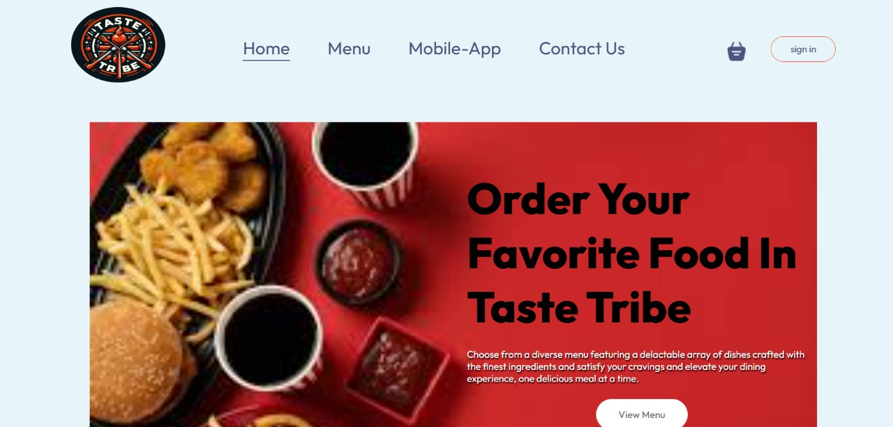

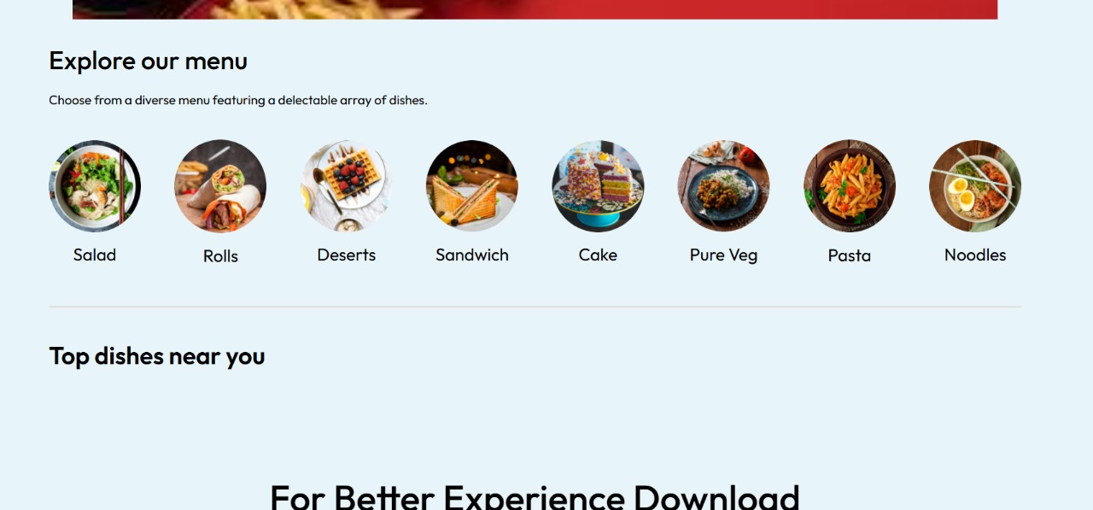

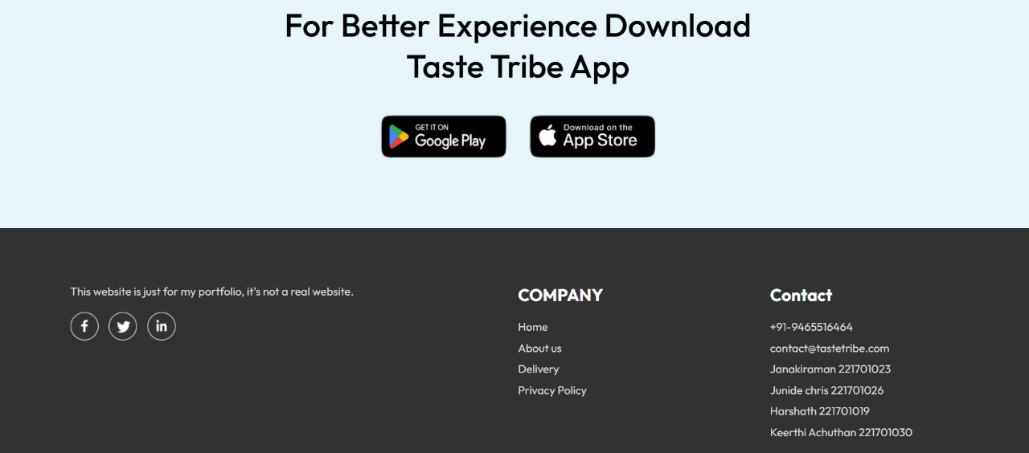

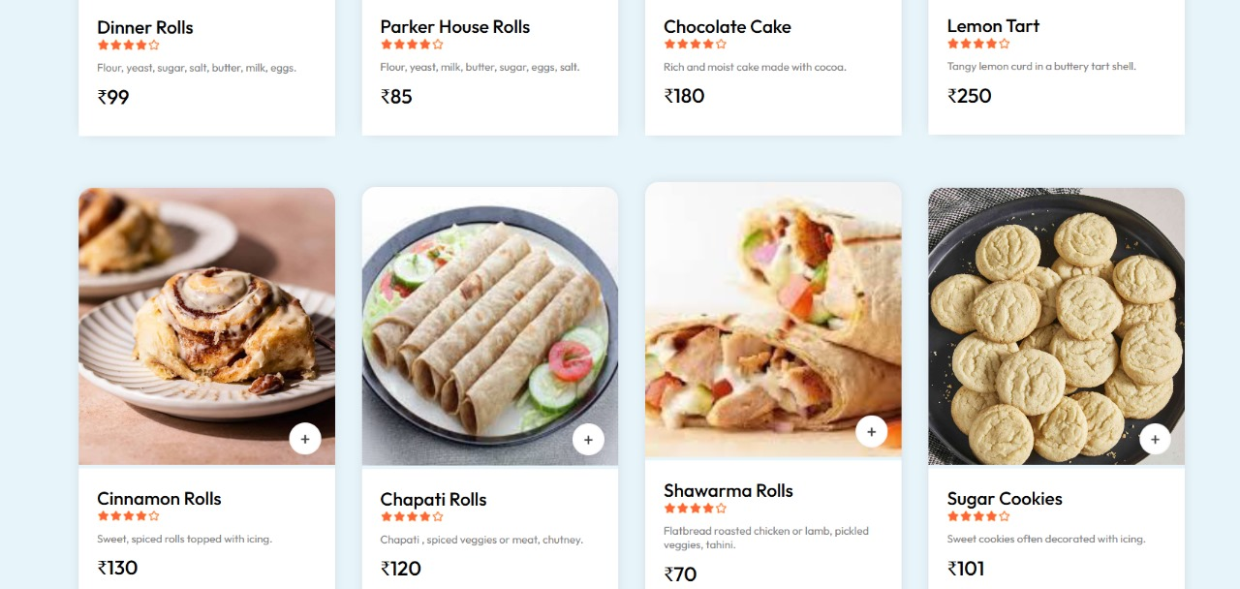

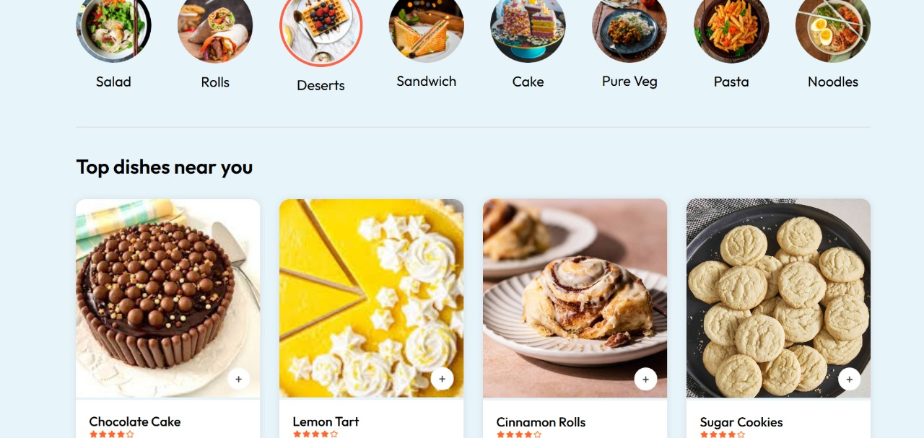

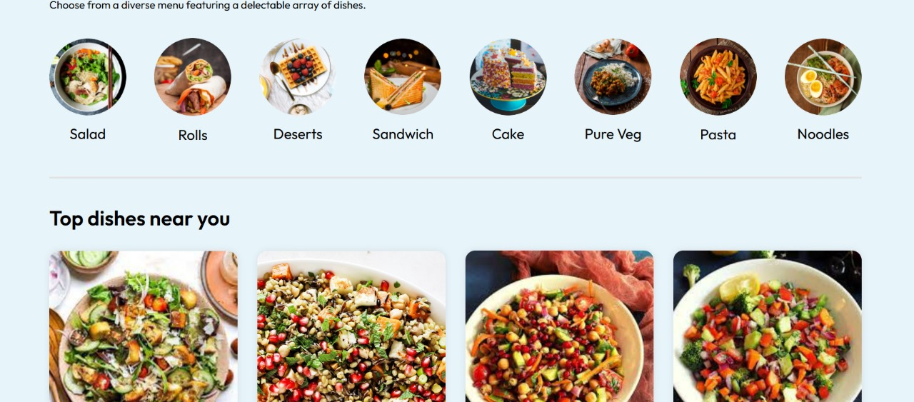

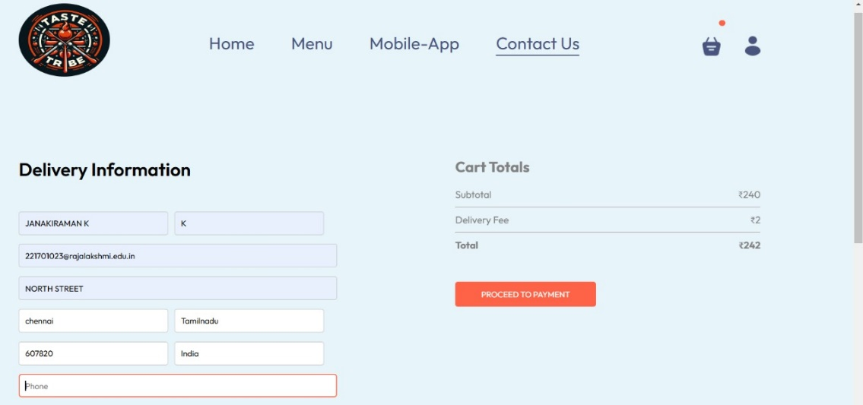

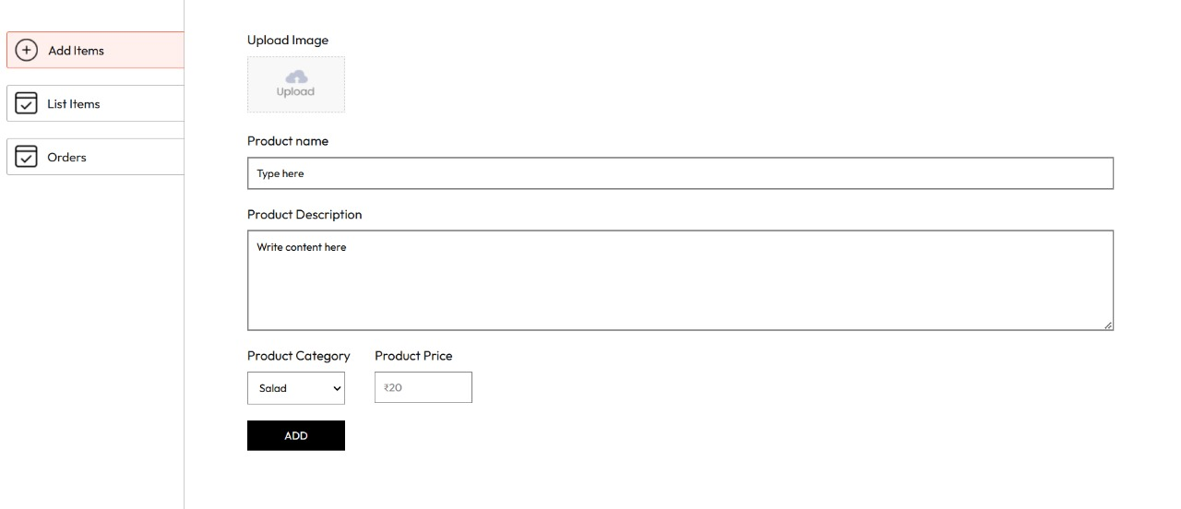

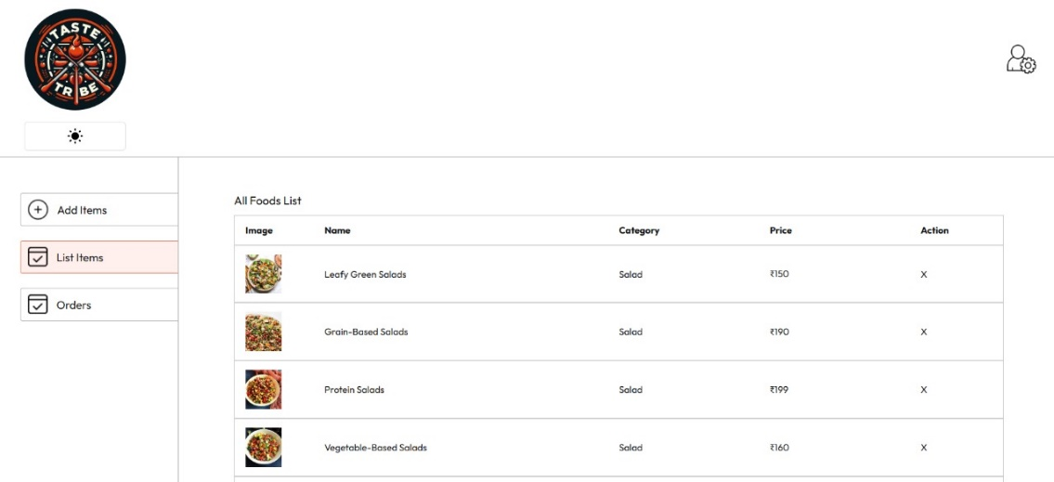

**CHAPTER 6**

**CONCLUSION AND FUTURE ENHANCEMENT**

The Food Delivery Management System offers a modern, efficient solution to the challenges faced by the traditional food delivery process. By integrating a comprehensive platform that connects customers, restaurant staff, and delivery personnel, this system enhances coordination and streamlines operations. The result is faster order processing, better tracking, and improved customer satisfaction. With features like real-time updates, secure payment processing, and data analytics, the system not only improves the end-user experience but also provides restaurants with valuable tools for growth and optimization. This project paves the way for more reliable and scalable food delivery services, ultimately setting a higher standard in the industry. The successful implementation of this system can transform food delivery into a more seamless, efficient, and customer-focused service.

**CHAPTER – 7**

**REFERENCES**

1. https://www.w3schools.com/sql/
2. https://www.tutorialspoint.com/sqlite/index.htm
3. <https://www.wikipedia.org/>
4. <https://www.learnpython.org/>
5. <https://www.codecademy.com/learn/learn-python>